**ATS Process – Incident’s Queue Manager**

**Task names: N/A**

|  |  |
| --- | --- |
| **Autor: Eduardo Osuna** | **Account: Trinity** |
| **Version: 1.0** | **Document type: Knowledge** |
| **Creation Date: 03/28/2021** | **Last Modification:** |
| **Owner: Eduardo Osuna** | **Last Modification made by:** |

**INCIDENT QUEUE MANAGEMENT**

Open the Incident tab, if the tab does not automatically go to the “unassigned self service incidents” option, it will need to be opened from the scroll down menu:

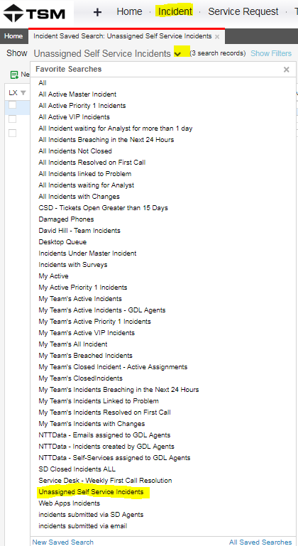

1. It is **imperative** that the incidents incoming are changed from “Logged” to “Active” status within **4 hours** at the most, that the incident came in otherwise we will be breaching the SLA stablished.

Highlight the incidents in “logged” status in the queue and click on the “Update Status to Active” button:

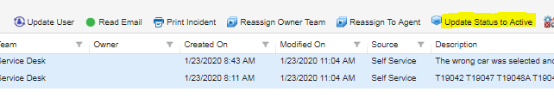

*SET SERVICE AND CATEGORY AS ‘SERVICEDESK’*

If you are not able to see the button, click on the “action menu” button and then select edit actions:

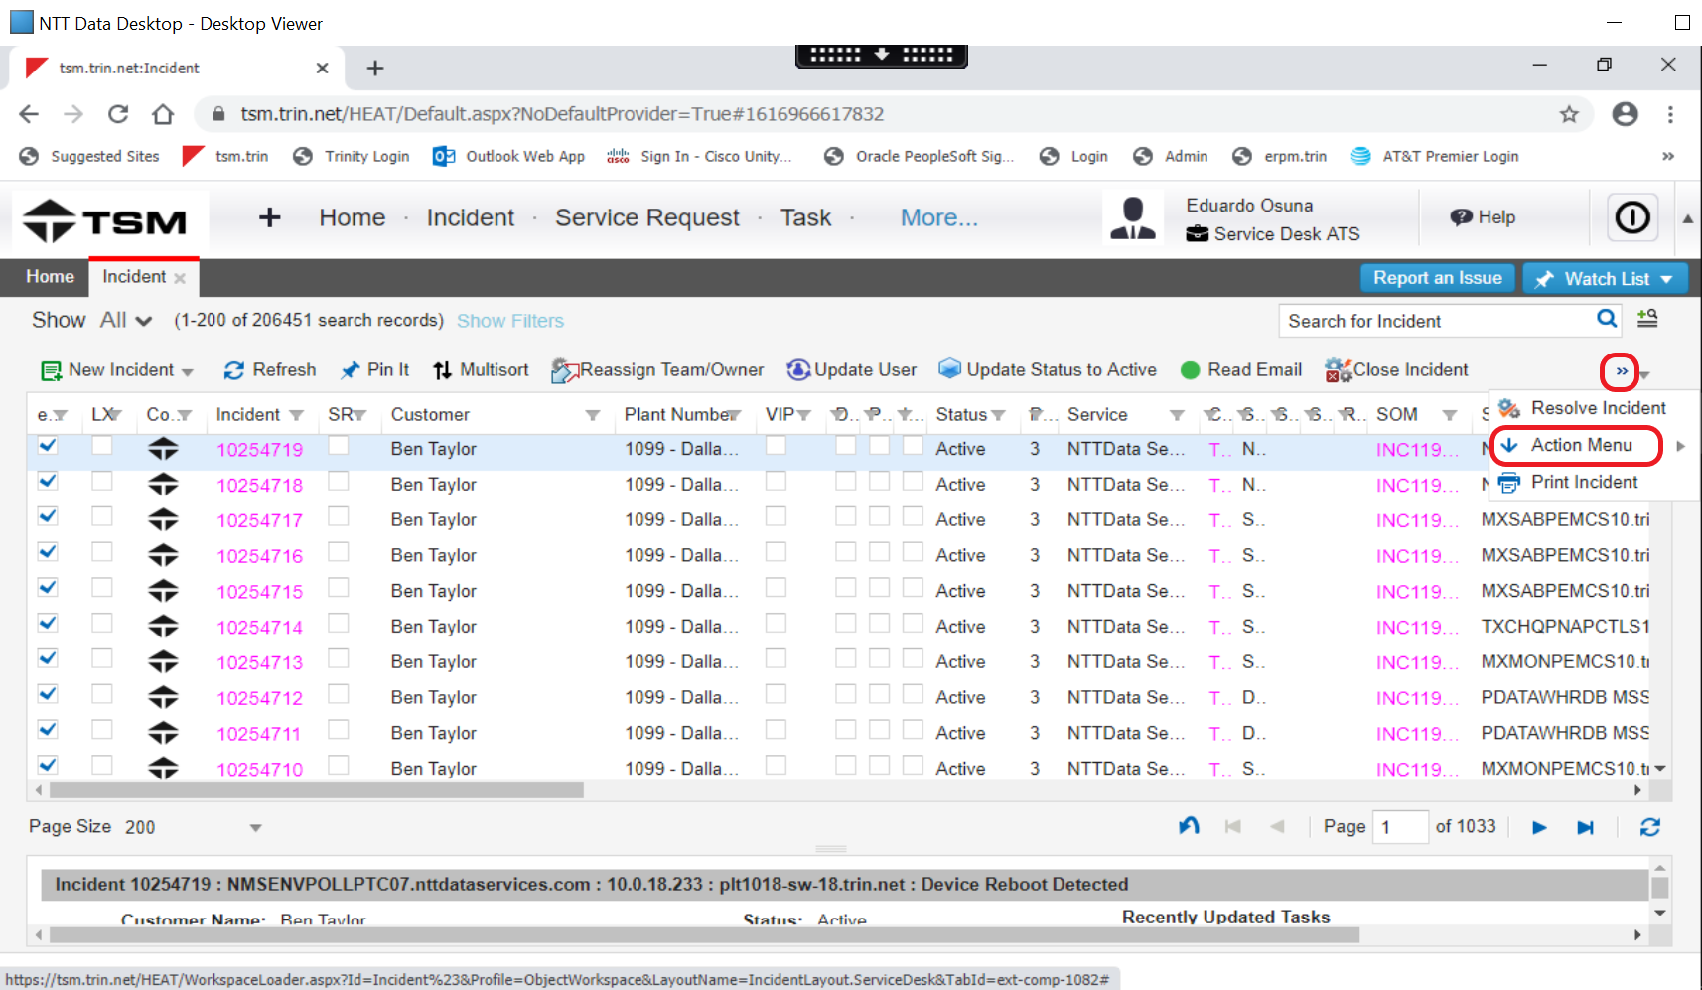

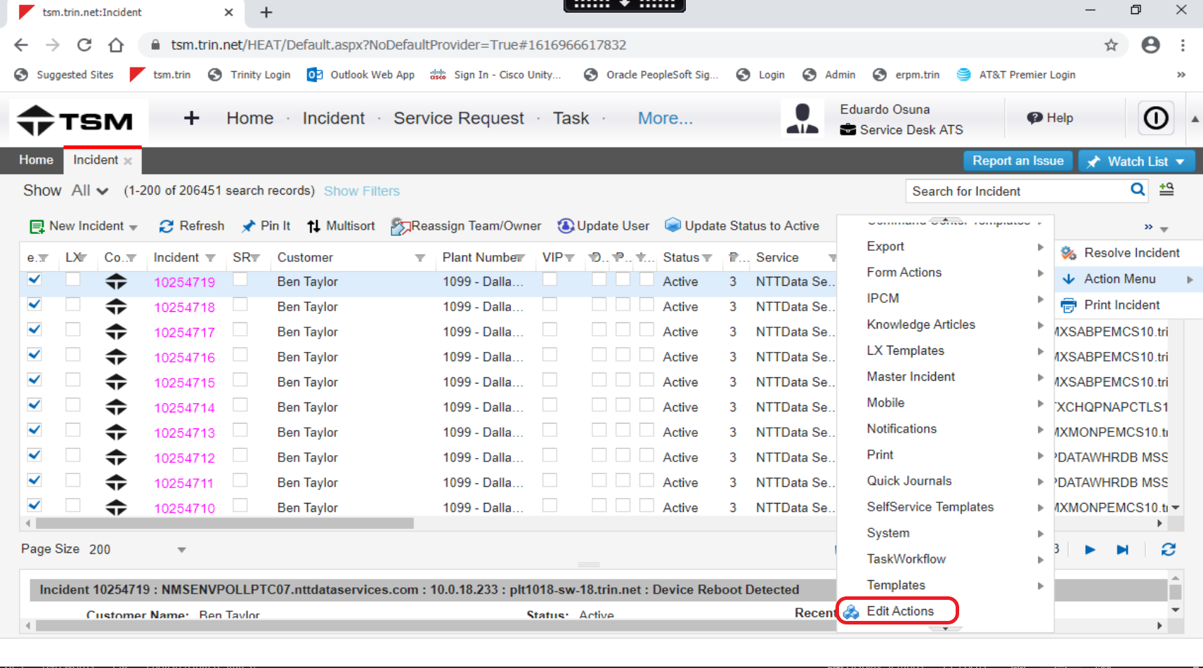

A new tab will open on your browser, in there you will go the left of the screen and open “form actions” menu. You will need to “drag and drop” in your menu that is in the top right portion of the screen:

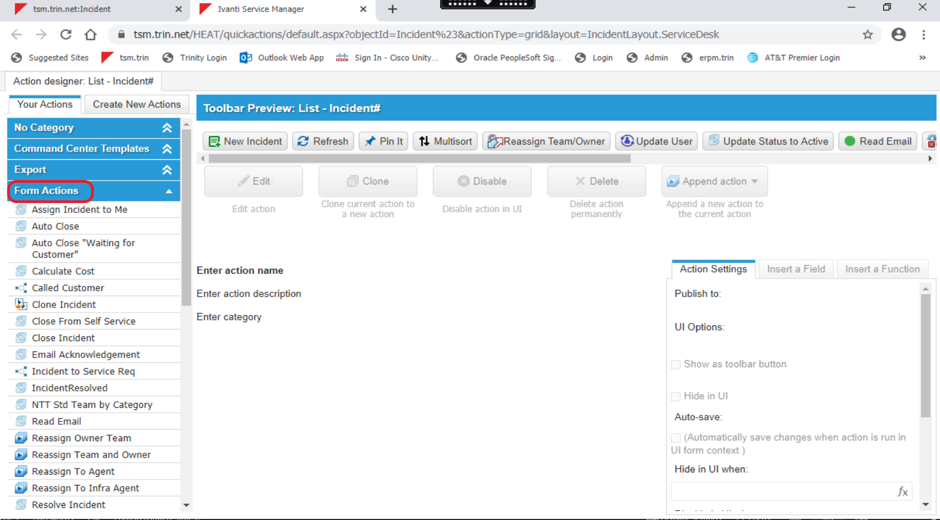

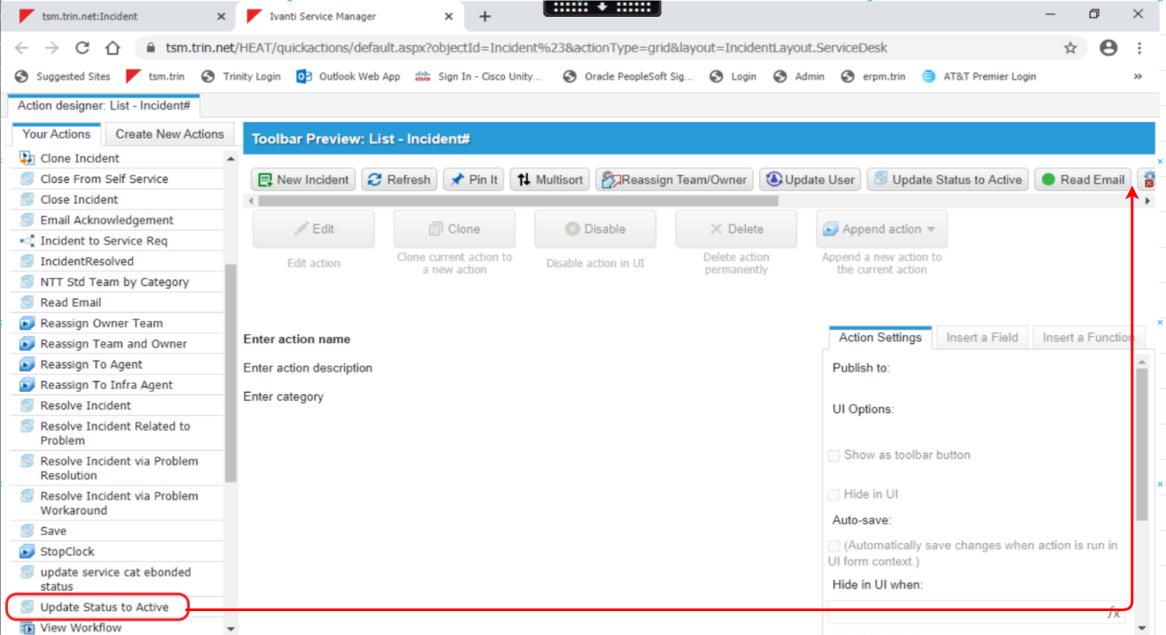

1. Exception reports incidents

There will be exception reports incoming to this queue, they need to be reviewed so that if nothing is reported, the ticket will be assigned to the person in charge of the Incident Queue and closed with the pertinent notes. On the other hand, if there is an exception reported, it will be assigned directly to the person in charge of the report that week.

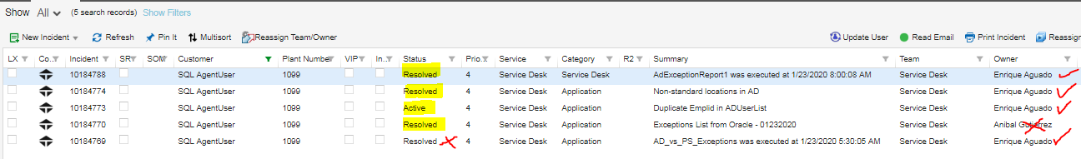

In the above example the owner is crossed with a red X because it was not assigned to the correct person and the status is crossed with a red X because that incident needs to be closed **ONLY** once the exits corresponding to the reported users in terminated status have been submitted and **not** before.

1. **Every** ticket needs to be opened and reviewed to determine the action taken. It is imperative to check the “activity history” tab in the ticket to determine if the ticket has been bounced back from another team. Generally more than 3 notes would mean that the ticket needs more attention as it may have been returned to our queue or additional notes have been included.

In the example below, the three notes highlighted, are the automatic ones every ticket has when they are opened.

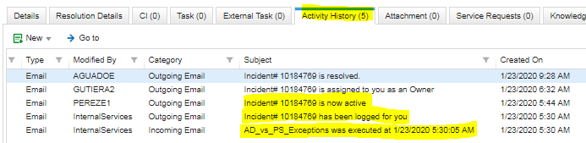

1. Tickets that need a service request opened need to be noted by us and handed over to a SD peer.
2. Tickets resolvable by our SD peers need to be assigned to them.

**TIP:** Use TSM to search in the knowledge base or in TSM “historic records” for similar cases to base on if the information available to you does not suffice and you become unsure on how to proceed.

You can do this by searching the user´s historic records:

Open the “employee” tab and then click on the “service requests” tab to search for similar cases, you may want to check under the “incidents” tab too for a lead.

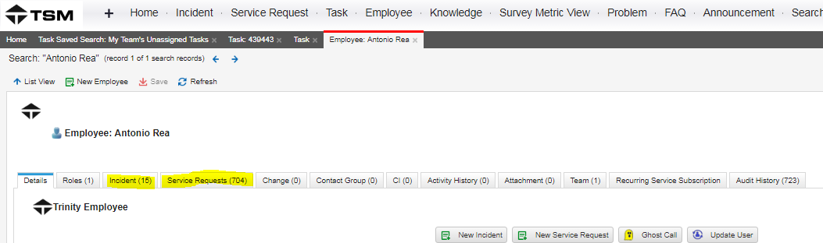

Search in general tickets related to the case. You can expand the search by filtering the summary column with key words related to your search.



1. All “Oracle Access Request Submitted” and “Oracle Access Removal” need to be assigned to you as you are the manager of the queue.

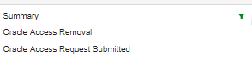

These incidents need to be worked in a timely manner as we have 3 days to have them completed or the SLA will breach. Refer to the Oracle Access document for further details.

1. Spanish tickets are routed to the Mexico Infrastructure team (**review** the case as it may have a solution on our end)
2. **Do not** assign in bulk to your own queue, we need to minimize touches and unnecessary assignments to the tickets reflect in the reports.

**NOTE:** New procedures are to be implemented regarding messaging tickets, for the moment they need to be reviewed by us and if procedure is unknown or restricted to our team, it needs to be consulted with Ryan Kinnear.